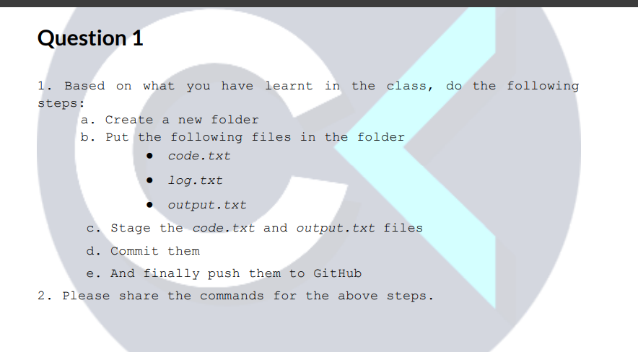

a. Create a new folder
mkdir Assignment_git
cd Assignment_git
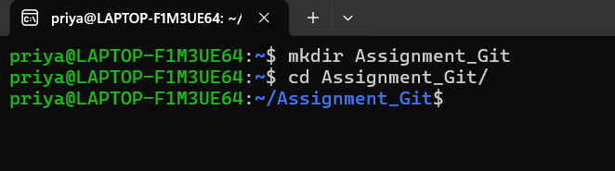

b. Put the following files in the folder ● code.txt ● log.txt ● output.txt
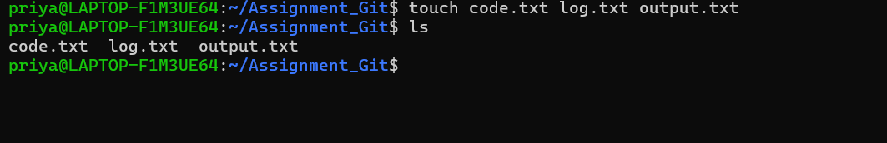
c. Stage the code.txt and output.txt files
To stage code.txt and output.txt , we need to initialize the git first as we have created new directory “Assignment.git”.
git init
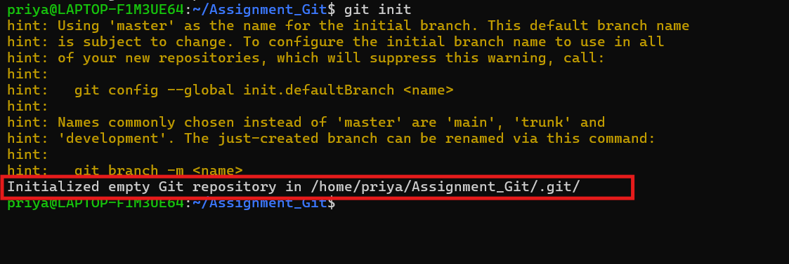
Explanation:
It converts a folder as git repository and creates hidden. git directory. Now git will track versions of files in this folder. This is done once per project(directory).
Now staging code.txt and output.txt:
git add code.txt output.txt
git status
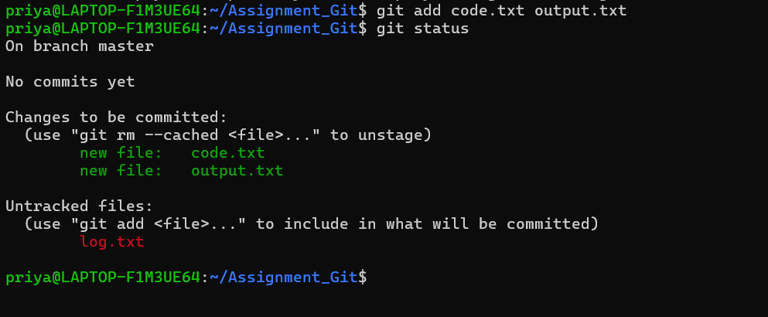
Explanation
- Staging means: “These are the files I want to include in the next commit”
- log.txt is not staged, so it will not be committed

d. Commit them
git commit -m "adding code.txt and output.txt file"
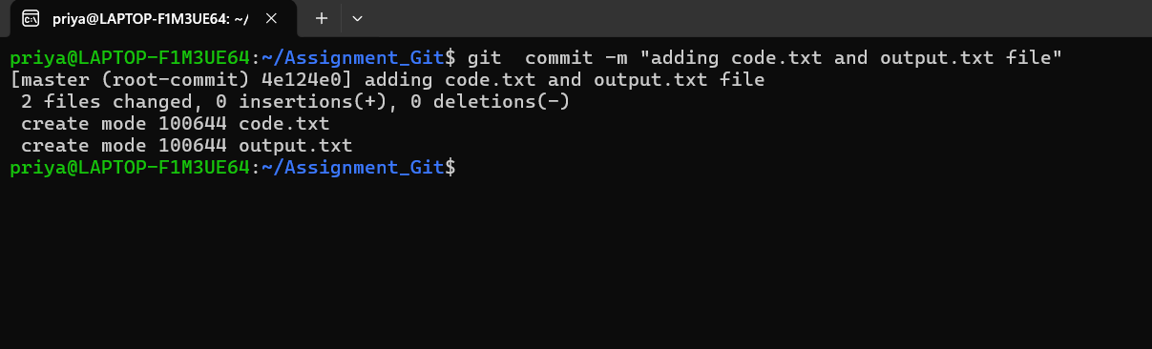
What it means
- We are creating a commit
- -m adds the commit message
- Only staged files are included in this commit
Line1#: Commit confirmation
[master (root-commit) 4e124e0] adding code.txt and output.txt file
- master
→ I’m on the master branch
- root-commit
→ This is the first commit in this repository
→ There were no commits before this
- 4e124e0
→ This is the short commit ID (hash)
→ It uniquely identifies this commit
- adding code.txt and output.txt file
→ The commit message I provided

Line2#: File change summary
2 files changed, 0 insertions(+), 0 deletions(-)
Explanation
- 2 files changed
→ code.txt and output.txt
- 0 insertions(+), 0 deletions(-)
→ Files were empty
→ No content was added or removed
→ Git still tracks the file creation
Line3#: File creation details
create mode 100644 code.txt
create mode 100644 output.txt
Explanation
- create mode
→ These files are being created in Git for the first time
- 100644 (file permissions)
Break it down:
  - 100 → regular file
  - 6 → owner has read + write
  - 4 → group has read only
  - 4 → others have read only
That means Owner can edit, everyone else can only read.
I checked git status only staged files are committed.
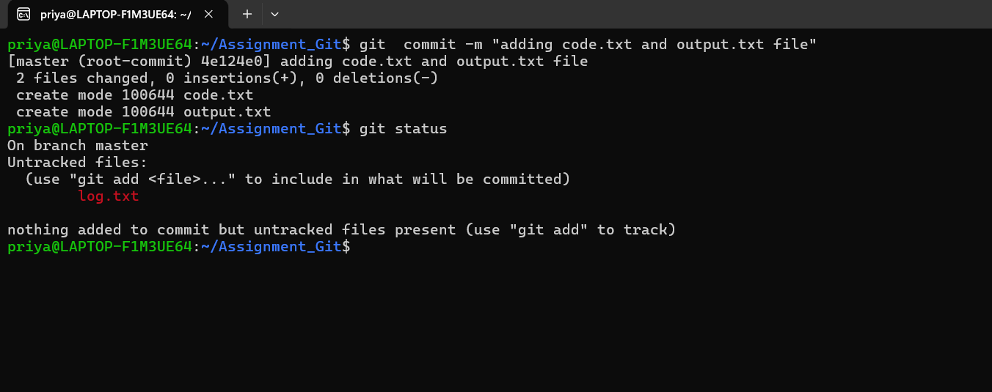
E. And finally push them to GitHub
“git remote -v displays the remote repositories linked to the local repo along with their fetch and push URLs.”
Currently no remote it added yet.
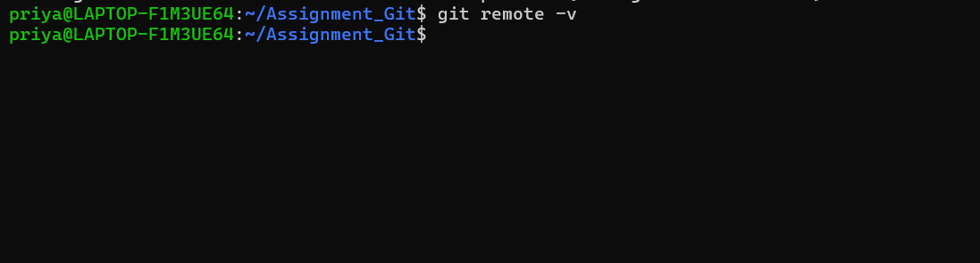
Note: we have already created local repo, so when you create a repository in gitlab uncheck README.md. why because it creates a README.md and creates a first commit on the remote and creates a default branch.
Now the remote has history and local also has history, if we try to push it, it will throw some error as Local and remote histories don’t match and Git refuses to overwrite remote history.
Then we must:
- Pull + merge
or
- Rebase
or
- Force push (dangerous)
Clear rule to remember
If we already have a local Git repository → do NOT initialize README on remote.
If you start directly on GitHub/GitLab → initialize README.
Interview-ready one-liner
“Unchecking ‘Initialize with README’ creates an empty remote repo, which allows a clean push from an existing local repository.”
git remote add origin https://gitlab.com/PriyaSettu/Assignment_Git.git
git remote -v now the remote repositories are linked.
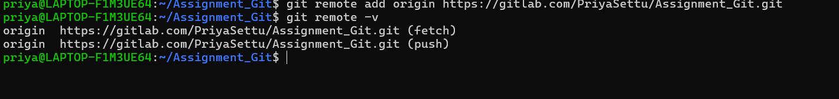
e. And finally push them to Gitlab
Profile → Edit profile → Access Tokens to create a token
GitLab token = password replacement for Git push over HTTPS
git push -u origin master
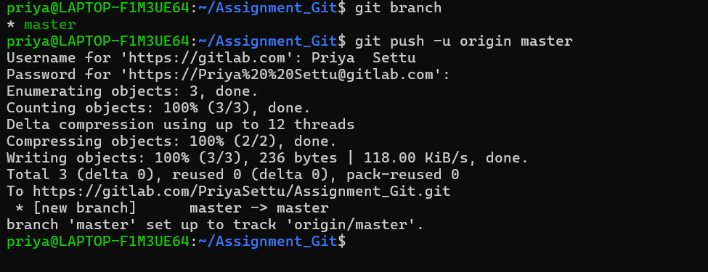
Explanation on high level: When we run the command git push -u origin master, Git sends our files from the computer to GitLab on the internet. First, Git asks for our username and a special password called a token to make sure it is really us. Then Git collects our files, packs them neatly, and uploads them to GitLab. Since this is the first time we are sending files, Git creates a new branch called master in GitLab. Finally, Git remembers this connection, so next time we can upload changes easily by using just the git push command.
Line by line Explanation:
git push -u origin master
This command sends all committed changes from the local master branch to the remote repository named origin (GitLab). The -u option tells Git to remember this branch connection, so future pushes and pulls can be done using simple commands.

Username for 'https://gitlab.com': Priya Settu
Git asks for the GitLab username to verify who is trying to upload the code to the remote repository.

Password for 'https://Priya%20%20Settu@gitlab.com':
Git asks for authentication. Here, the password is a Personal Access Token, not the GitLab account password. The token is used to securely allow access to the repository.

Enumerating objects: 3, done.
Git identifies and lists all the objects (files, commits, and related data) that need to be sent to GitLab.

Counting objects: 100% (3/3), done.
Git counts all identified objects and confirms that all required objects are ready for upload.

Delta compression using up to 12 threads
Git prepares the data for transfer by compressing it and uses multiple CPU threads to speed up the process.

Compressing objects: 100% (2/2), done.
Git has successfully compressed the objects so that they take less space during transfer.

Writing objects: 100% (3/3), 236 bytes | 118.00 KiB/s, done.
Git uploads the compressed data to the GitLab server. This line confirms that all objects were uploaded successfully and shows the data size and upload speed.

Total 3 (delta 0), reused 0 (delta 0), pack-reused 0
This line shows technical information. It means all objects were newly uploaded, no previous data was reused, and no differences (deltas) were applied.

To https://gitlab.com/PriyaSettu/Assignment_Git.git
This is the URL of the GitLab repository where the data was uploaded.

* [new branch] master -> master
A new branch named master was created in the remote GitLab repository, and the local master branch was pushed to it.

branch 'master' set up to track 'origin/master'.
Git has linked the local master branch with the remote origin/master branch. This allows future git push and git pull commands to work without specifying the branch name.

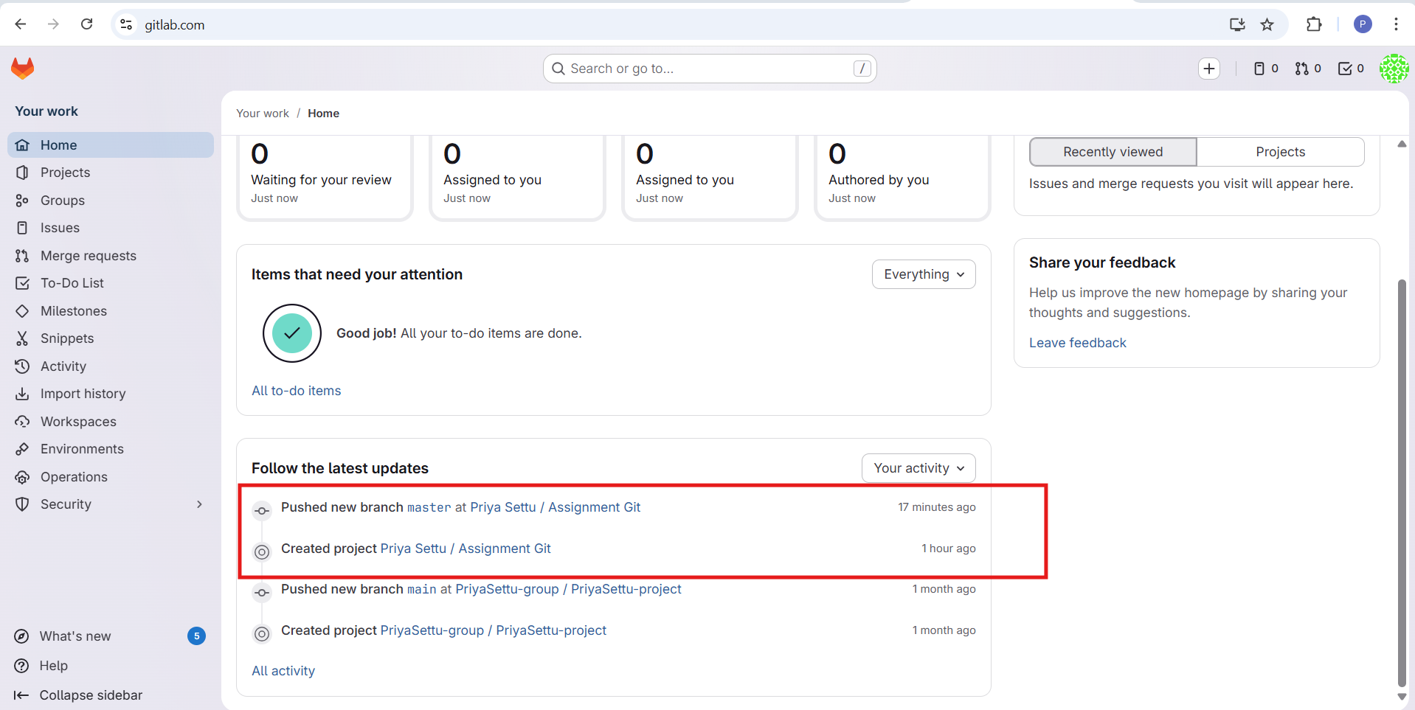
The committed files are successfully pushed to remote repository in gitlab.
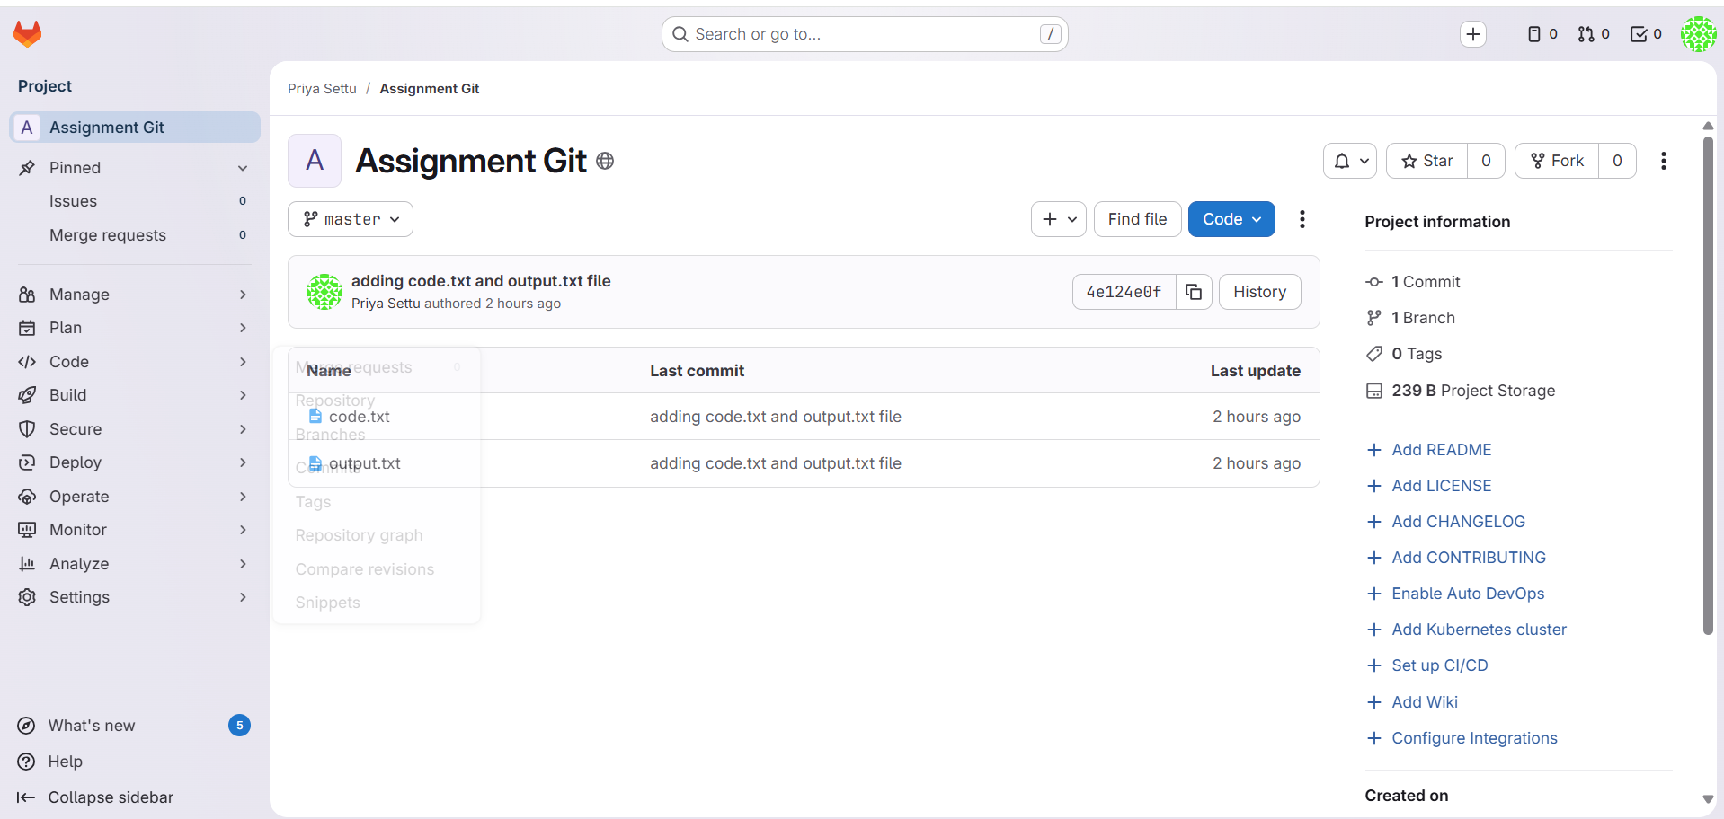

2. Please share the commands for the above steps.

mkdir Assignment_git
cd Assignment_git
git init
git add code.txt output.txt
git status
git commit -m "adding code.txt and output.txt file"
git remote add origin https://gitlab.com/PriyaSettu/Assignment_Git.git
git remote -v
git push -u origin masters

